**EECS 360**

**Lab 5**

**Chen Long**

**2016/9/26**

**Objective**

The goal of this lab is to help us understand how to use cosine function and exponential function with imaginary number. Also, we need to implement the summation by using symsum.

**Description**

The first two problems are about the exponential and cosine function, which we have done some of them on the previous lab, however, what’s new and really helpful to us is that we have a new plotting skill to use, which is the marking sign. We have to do three types of mark in the second graph, which are diamond, *, and circle. The way we can use them is to add a commend in the plot statement, we can write it as “plot (x, y, ’o’)”, depends on which mark you wish, you can change from ‘o’ to ‘d’ or ‘*’. Also, as what we have done before, if you wish to have two plots in one graph, you can always put a ‘hold on’ commend after a plot statement.

The last two question is about summation, on Exercise 5.2, we can find out that the x(t) function is a summation form of (4/pi) * (1/(2n+1)) cos((2n+1) * t-pi/2), and y(t) is a summation form of cos(2nt), and z(t) is a summation form of ((1/(2n+1)).^2)*cos((2n+1)*t.

On the last problem, we should plot these three function out by “symsum” statement. The syntax of symsum is “symsum (expression, n, starting number, ending number)”. However, we found that by using “symsum” takes way too long to implement these graph, therefore I decide to use for loop instead, and it takes only 2 seconds to finish graphing the function.

**Result**

The result comes out the same as what we expected, as what is shown in the graph, the more summation we do, the more linear the graph will be since it approach more to the step function.

**Conclusion**

This Lab is a starting point for us to work on Fourier Series, it really helps me to understand how Fourier Series is so useful, I didn’t know it before until I graph it out by MATLAB.

clear all;

% part a);

figure (1);

t=-1:0.01:1;

x=exp(4*pi*j*t)+exp(-4*pi*j*t);

y=(exp(4*pi*j*t)-exp(-4*pi*j*t))/1i;

plot(t,x);

hold on;

plot(t,y);

legend('y','z');

xlabel('t');

% part b);

t=-1:0.001:1;

figure (2);

z1=8*cos(2*pi*t-pi/2);

z2=8*cos(2*pi*t-pi);

z3=8*cos(2*pi*t-3*pi/2);

plot(t,z1,'*');

hold on;

plot(t,z2,'d');

hold on;

plot(t,z3,'o');

legend('z1','z2','z3');

xlabel('t');

% part c)

figure (3);

p=-1:0.001:1;

p1=3*cos(8*pi*p-pi/2);

p2=3*cos(8*pi*p-pi);

p3=3*cos(8*pi*p-3*pi/2);

plot(p,p1,'*');

hold on;

plot(p,p2,'d');

hold on;

plot(p,p3,'o');

legend('p1','p2','p3');

xlabel('p');

% Exercise 5.2

% (4/pi)*(1/(2n+1))cos((2n+1)*t-pi/2)

% cos(2nt)

% ((1/(2n+1)).^2)*cos((2n+1)*t

% Exercise 5.3

figure (4);

% subplot 1

t=-8:0.01:8;

x1=(4/pi)*cos(t-pi/2);

subplot(321);

legend('x1');

plot(t,x1);

% subplot 2

subplot(322);

plot(t,x1); hold on;

x2=(4/(3*pi))*cos(3*t-pi/2);

plot(t,x2); hold on;

sx2=x1+x2;

plot(t,sx2);

legend('x1','x2','sx2');

% subplot 3

subplot(323);

plot(t,x1); hold on;

x2=(4/3*pi)*cos(3*t-pi/2);

plot(t,x2); hold on;

x3=(4/5*pi)*cos(5*t-pi/2);

plot(t,x3); hold on;

sx3=x1+x2+x3;

plot(t,sx3);

legend('x1','x2','x3','sx3');

% subplot 4

sx4=0;

m=10;

for n=0:m

sx4=(4/pi)*(1/(2*n+1))*cos((2*n+1)*t-pi/2)+sx4;

end;

subplot(324);

plot(t,sx4);

legend('sx4');

% subplot 5

sx5=0;

m=25;

for n=0:m

sx5=(4/pi)*(1/(2*n+1))*cos((2*n+1)*t-pi/2)+sx5;

end;

subplot(325);

plot(t,sx5);

legend('sx5');

% subplot 6

sx6=0;

m=50;

for n=0:m

sx6=(4/pi)*(1/(2*n+1))*cos((2*n+1)*t-pi/2)+sx6;

end;

subplot(326);

plot(t,sx6);

legend('sx6');

% y function graphing

% Exercise 5.3

figure (5);

% subplot 1

t=-8:0.01:8;

y1=cos(t);

subplot(321);

plot(t,y1);

legend('y1');

% subplot 2

subplot(322);

plot(t,y1); hold on;

y2=cos(2*t);

plot(t,y2); hold on;

sy2=y1+y2;

plot(t,sy2);

legend('y1','y2','sy2');

% subplot 3

subplot(323);

plot(t,y1); hold on;

y2=cos(2*t);

plot(t,y2); hold on;

y3=cos(3*t);

plot(t,y3); hold on;

sy3=y1+y2+y3;

plot(t,sy3);

legend('y1','y2','y3','sy3');

% subplot 4

sy4=0;

m=10;

for n=0:m

sy4=cos((n+1)*t)+sy4;

end;

subplot(324);

plot(t,sy4);

legend('sy4');

% subplot 5

sy5=0;

m=25;

for n=0:m

sy5=cos((n+1)*t)+sy5;

end;

subplot(325);

plot(t,sy5);

legend('sy5');

% subplot 6

sx6=0;

m=50;

for n=0:m

sx6=cos((n+1)*t)+sx6;

end;

subplot(326);

plot(t,sx6);

legend('sy6');

% z function graphing

% Exercise 5.3

figure (6);

% subplot 1

t=-8:0.01:8;

y1=cos(t);

subplot(321);

plot(t,y1);

legend('z1');

% subplot 2

subplot(322);

plot(t,y1); hold on;

y2=(1/9)*cos(3*t);

plot(t,y2); hold on;

sy2=y1+y2;

plot(t,sy2);

legend('z1','z2','sz2');

% subplot 3

subplot(323);

plot(t,y1); hold on;

plot(t,y2); hold on;

y3=(1/25)*cos(5*t);

plot(t,y3); hold on;

sy3=y1+y2+y3;

plot(t,sy3);

legend('z1','z2','z3','sz3');

% subplot 4

sy4=0;

m=10;

for n=0:m

sy4=((1/(2*n+1)).^(2))*cos((2*n+1)*t)+sy4;

end;

subplot(324);

plot(t,sy4);

legend('sz4');

% subplot 5

sy5=0;

m=25;

for n=0:m

sy5=((1/(2*n+1)).^(2))*cos((2*n+1)*t)+sy5;

end;

subplot(325);

plot(t,sy5);

legend('sz5');

% subplot 9

sx6=0;

m=50;

for n=0:m

sx6=((1/(2*n+1)).^(2))*cos((2*n+1)*t)+sx6;

end;

subplot(326);

plot(t,sx6);

legend('sz6');

Figure 1

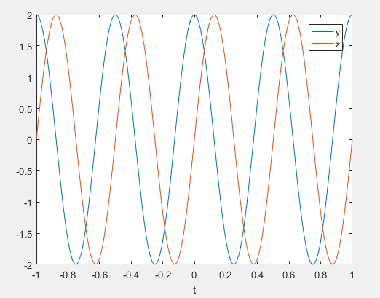

Figure 2

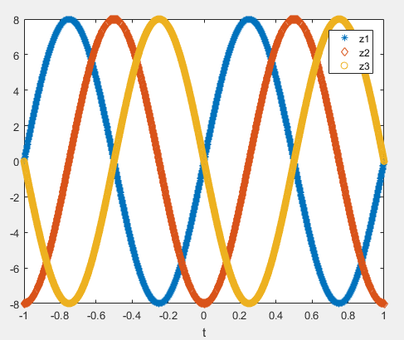

Figure 3

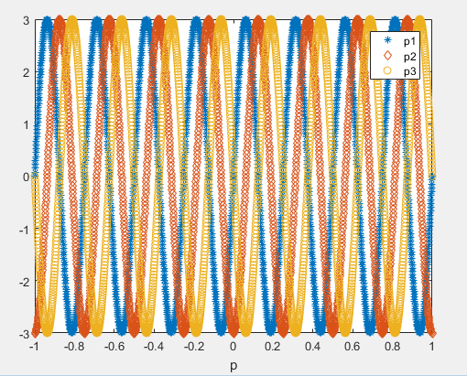

Figure 4

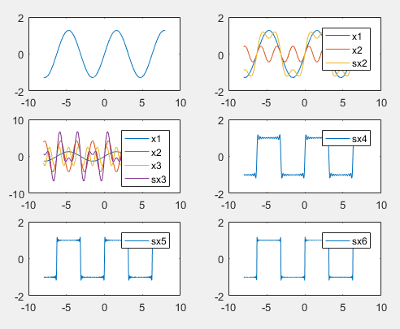

Figure 5

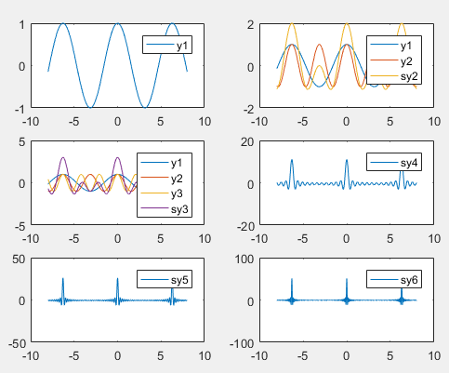

Figure 6

